Priscilla Hopkirk, Villanova political science professor, dies at 98
“In a certain sense, she was a fighter because she had to be a fighter,” said son Arthur Hopkirk. "She was courageous about many things."
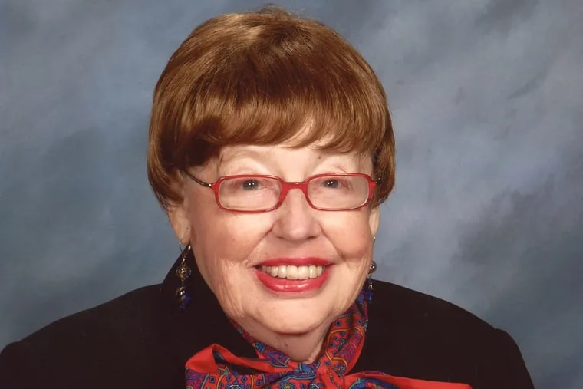Priscilla Marguerite Greeley HopkirkCourtesy of the Hopkirk family
Our thanks goes to Rita Giordano of The Philadelphia Inquirer for this wonderful obituary about Priscilla. Updated Jul 9, 2021
Priscilla Marguerite Greeley Hopkirk, 98, a trailblazer for women’s rights and longtime Villanova University political science professor, died Tuesday, June 22, from pneumonia at Sunrise of Granite Run, an assisted living facility near Media.
Despite disappointments and mistreatment early in her career that would have been illegal today, the determined Mrs. Hopkirk went on to years of service at Villanova starting in 1967, when she was hired as an assistant professor and the first woman in the political science department. She chaired the department from 1978 to 1988 — again being the first woman to do so. She left Villanova in 1994.
“In a certain sense, she was a fighter because she had to be a fighter,” said a son, Arthur Hopkirk.
That was true in her career and also later in life when she refused to give in to failing health, he said.
“She was courageous about many things,” he said.
Mrs. Hopkirk was born in Schenectady, N.Y., and grew up in Boston and Belmont, Mass., the only child of Arthur Lewis Greeley, a chemistry instructor and textbook editor, and Ella Marguerite Greeley, a librarian and amateur artist.
She enrolled in what was then Radcliffe College, an affiliate of Harvard University. At Radcliffe, women paid higher tuition than men at Harvard College, also part of the university, were limited in their use of Harvard’s main library, and, in her experience, could not be in the same classrooms as men until male students started leaving for World War II.
In her first semester, however, she took a course taught by Samuel Beer, a former reporter and speechwriter for Franklin D. Roosevelt, that changed her life. He so inspired Mrs. Hopkirk that she decided to major in government. She received her bachelor’s degree from Radcliffe and then her master’s and, in 1952, her Ph.D., both in government from Harvard. She was often one of only a few women in a class or program, her son said.
And yet back then, such academic accomplishments didn’t win young women many opportunities. Mrs. Hopkirk’s son said that early in her career, his mother sent out about 400 resumés and got no interviews. One potential employer wrote back that he was impressed by her credentials but would rather hire a man.
After some temporary teaching jobs, she was finally hired as an assistant professor at Skidmore College in Saratoga Springs, N.Y. While at a meeting of the American Society for Public Administration in New York City, she met John W. Hopkirk, a fellow political scientist. They were wed in 1957.
After moving to Delaware County in 1960, Mrs. Hopkirk taught evening courses at Rutgers University’s Camden campus and summer and evening courses at Pennsylvania Military College/Penn Morton College, which is now Widener University in Chester. Then she was hired at Villanova.
Mrs. Hopkirk’s husband was a supporter of women’s rights and his wife’s career. They traveled the world together, visiting dozens of countries and all the continents except Antarctica. She enjoyed ballroom dancing with her husband into her 80s. Mr. Hopkirk died in 2006 after almost 49 years of marriage.
In her last 14 years of life, Mrs. Hopkirk overcame numerous health crises, including cancer, stroke, and fractures, surprising her doctors and family alike. Even as she entered a rehabilitation facility after a stroke at age 96, she asked for a copy of Michelle Obama’s autobiography because she was scheduled to lead a discussion on it for her book club, her son said.
Mrs. Hopkirk was also active in civic and professional organizations. She was chair of the Delaware County Council of the League of Women Voters from 1966 to 1968, and she remained active in the league through retirement. She was president of the Pennsylvania Political Science Association, an officer of the Northeastern Political Science Association, and was active in the Philadelphia chapter of the American Society for Public Administration.
She was a member of the Unitarian Universalist Church of Delaware County in Media for 60 years, serving twice on its board of trustees as president and singing with the church’s chorus for over 40 years.
Mrs. Hopkirk is also survived by another son, Howard; two grandchildren; and other relatives.
A memorial service will be held later this year at the Unitarian Universalist Church of Delaware County.
Contributions in her memory may be made to the Unitarian Universalist Church of Delaware County, 145 W. Rose Tree Rd., Media, Pa. 19063, or Villanova University, 800 E. Lancaster Ave., Villanova, Pa. 19085, or Villanova.edu, or the Fox Chase Cancer Center, 333 Cottman Ave., Philadelphia, Pa. 19111, or foxchase.org.
Published
July 9, 2021

